INTERNATIONAL STUDENT LEADERSHIP PROGRAM
Connecting Global Citizenship and Student Learning

DEVELOPING STUDENTS AS GLOBAL LEADERS
The International Student Leadership Program at Cal Poly Pomona University offers students who desire careers in the global marketplace a competitive edge by developing their leadership abilities, communication skills, and understanding of our interconnected world. Students will gain valuable insights and friendships that will endure a lifetime.

ABOUT THE PROGRAM
Program fee includes:
• Academic courses and campus activities
• Lodging (Double occupancy including breakfast)
• Airport pick-up and drop-off, ground transportation for the academic field trips and cultural tours on weekends

Term | Date (2016) | Fee | VISA | App Deadline
2016 Winter | Jan 31 – Feb 13 | $2,980/ student | B1/2 | Jan 10, 2016

FEATURES
• High-quality college lectures and workshops
• Seasoned instructors considered experts in the field
• Relevant topics:
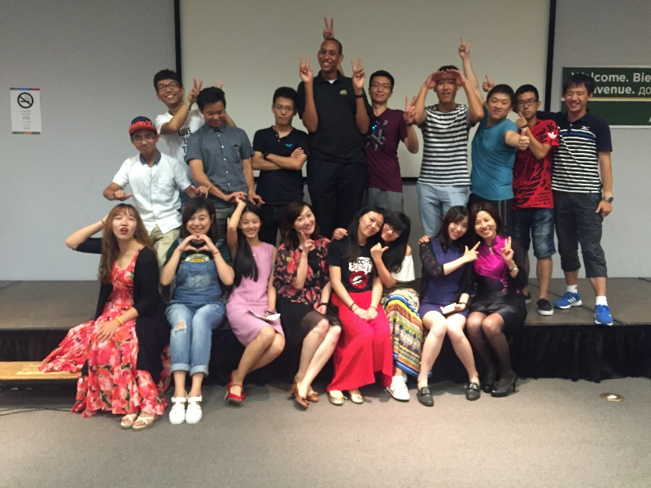
- Leadership
- Cross cultural communication
- Team building
- Problem solving
- Strategic planning
- Public speaking
- English language
- American culture
• Classes conducted in English only for maximum language exposure and fluency
• Final project showcases the student’s newly acquired skills

ADVANTAGES
• “Learn by Doing” philosophy means students put into action what they learn and will leave with real-world experience.
• Discover your individual leadership style through projects based on teamwork rather than competition. Learn how to work with people of different leadership styles to achieve success.
• Grow your inner strengths. The program focuses on developing skills for creative thinking and problem solving.
• Make lifelong friendships and connections in the U.S.

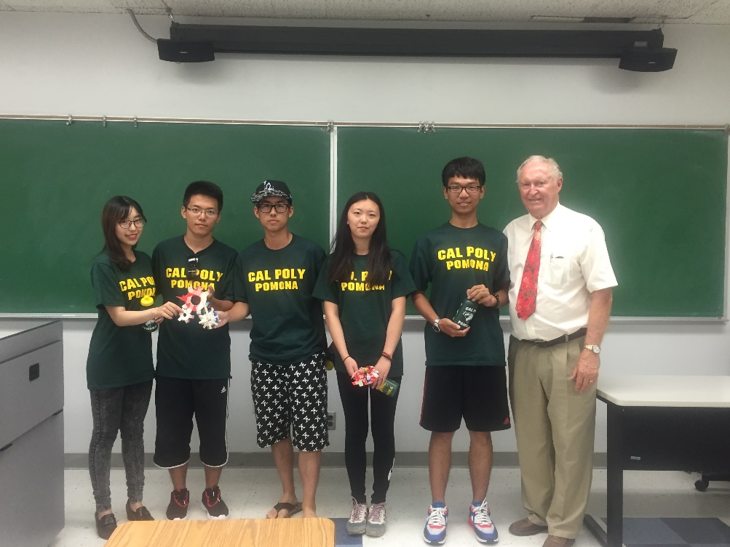
ABOUT CAL POLY POMONA
Quality Learning Experience
• Quality faculty with success and experience
• Strong connection to professional world
• Quality and currency of teaching
• Engagement and commitment of teaching

Highly Ranked
• Ranks among the best universities in the country
• A diverse, learn-by-doing university
• Graduates with the skills needed to succeed in a dynamic, evolving work environment

Polytechnic “Learn by Doing”
• Weave technology and hands-on learning experiences into academic programs
• Bring textbook concepts to life in a technologically advanced and multicultural world
• A multi-faceted approach to problem solving
• Looking at a situation from all possible angles

PRIME LOCATION
Cal Poly Pomona is conveniently located in Southern California, close to beaches, mountain resorts, and desert enclaves. Los Angeles, Palm Springs, San Diego, Disneyland, and Hollywood

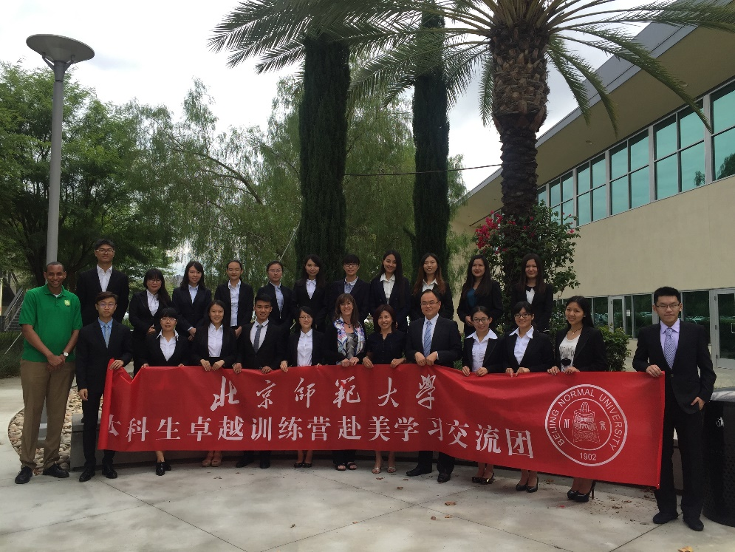
CONTACT US
For more information contact:

Candy Tan
Phone: 909.979.6619
Email: yingtan@cpp.edu
Website: www.ceu.cpp.edu/go/gep

College of the Extended University
3801 West Temple Avenue
Pomona, CA 91768

